**ANALYZING ROAD SAFETY IN THE UK**

### Submitted By

**K MITHUN RAM(192124213)**

Guided by **K.Mangaiyarkarasi** Research Scholar Department of Deep Learning

#### https://lh3.googleusercontent.com/LDBH0Mxv8ERA4XaYff0ayw6_p0mBadusK0ZMLMSfUX2m9KEGtSM-_-Vmgy8saNzVueBfh6to61pZdqwk9oqURhxQPGpKiIhw4fRuREBx4s0e9RjOECPDKnHsLTQVdtO6C4Qs1-mQDepartment of Computer Science and Engineering,

**Saveetha School of Engineering, SIMATS Thandalam, Chennai**

# PROBLEM STATEMENT

**Introduction:**

Analyzing road safety in the United Kingdom is imperative for minimizing accidents and ensuring the well-being of road users. This overview delves into key factors, including accident statistics, driver behavior, infrastructure assessment, and policy effectiveness. The goal is to continuously enhance road safety, employing data-driven strategies and interventions to create safer transportation systems for UK citizens.

### Problem Statement :

1. Evaluate the median severity value of accidents caused by motorcycle.
2. Evaluate accidents severity and total accidents per vehicle type.
3. Calculate the average severity by vehicle type
4. Calculate the average severity and total accidents by motorcycle.

# DATASET ANALYSIS

##### Dataset Analysis of UK Road Safety Data Motorcycle Accidents:

* Median severity value for motorcycle accidents: 3.0
* Indicates the typical accident severity for motorcycles.

##### Accidents Severity by Vehicle Type:

* Mean severity and total accidents for various vehicle types.
* Car, Bus, Truck, and Motorcycle accident data evaluated.

##### Average Severity by Vehicle Type:

* Calculated the average accident severity for each vehicle type.
* Insight into severity levels based on vehicle types.

##### Motorcycle Accidents:

* Focused analysis on motorcycle accidents.
* Found an average severity of approximately 2.86.
* A total of 736 motorcycle accidents recorded.

##### Conclusion:

The analysis provides insights into accident severity and its distribution among different vehicle types.Valuable information for improving road safety measures and reducing accidents involving motorcycles.

# ENVIRONMENTAL SETUP

**Python Development Environment**: Google Colab

**Google Colab** is a powerful and popular cloud-based Python environment for data science, machine learning, and data analysis.

**Libraries Used:**

**Pandas:** Pandas is essential for data manipulation and analysis, providing data structures like Data Frames and tools for data cleaning and pre-processing.

**NumPy:** NumPy offers support for large, multi-dimensional arrays and matrices. It's crucial for numerical computing in Python.

**Matplotlib:** Matplotlib is a versatile library for creating static, animated, and interactive visualizations in Python.

**Seaborn:** Seaborn is a high-level interface for drawing attractive and informative statistical graphics, built on top of Matplotlib.

**Plotly:** Plotly is used for creating interactive, web-based visualizations. It's great for dashboards and data presentation.

**Scikit-Learn**: Scikit-Learn provides simple and efficient tools for data mining and data analysis. It's widely used for machine learning.

**SciPy**: SciPy builds on NumPy and provides additional functionality for optimization, linear algebra, integration, interpolation, and more.

**FLOW DIAGRAM**

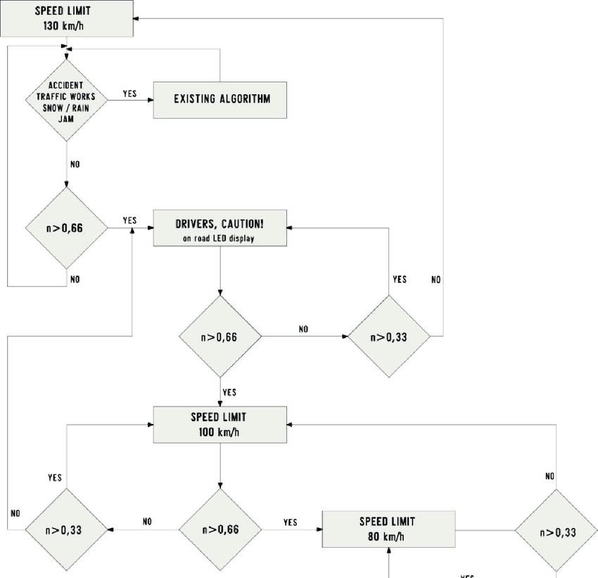

**CODE SKELETON**

import pandas as pd import numpy as np

import matplotlib.pyplot as plt import plotly

import plotly.express as ex import seaborn as sns

from sklearn.preprocessing import StandardScaler from scipy.stats import norm

from sklearn.preprocessing import LabelEncoder from sklearn. model_selection import cross_val_score from sklearn.linear_model import LogisticRegression sns.set(style='whitegrid', color_codes=True)

from google.colab import files uploaded = files.upload() file_name = 'UK_Accident.csv' df = pd.read_csv(file_name) final_df = df

final_df.shape final_df.sample(4) print(final_df.info())

# #1)

motorcycle_accidents = final_df[final_df['Vehicle_Type'] == 'Motorcycle'] median_severity = motorcycle_accidents['Accident_Severity'].median() print(f"Median Severity Value for Motorcycle Accidents: {median_severity}") #

#2.

accidental_severity = df.groupby('Vehicle_Type')['Accident_Severity'].median()

total_accidents = df['Vehicle_Type'].value_counts()

result_df = pd.DataFrame({'Median_Accidental_Severity': accidental_severity, 'Total_Accidents': total_accidents})

print(result_df)

# #3.

average_severity = df.groupby('Vehicle_Type')['Accident_Severity'].mean() result_df = pd.DataFrame({'Average_Accidental_Severity': average_severity}) print(result_df)

# #4.

motorcycle_accidents = df[df['Vehicle_Type'] == 'Motorcycle'] average_severity = motorcycle_accidents['Accident_Severity'].mean() total_accidents = len(motorcycle_accidents)

print(f"Average Severity for Motorcycle Accidents: {average_severity}") print(f"Total Motorcycle Accidents: {total_accidents}")

## RESULT ANALYSIS

**Output**

1) Median Severity Value for Motorcycle Accidents: 3.0

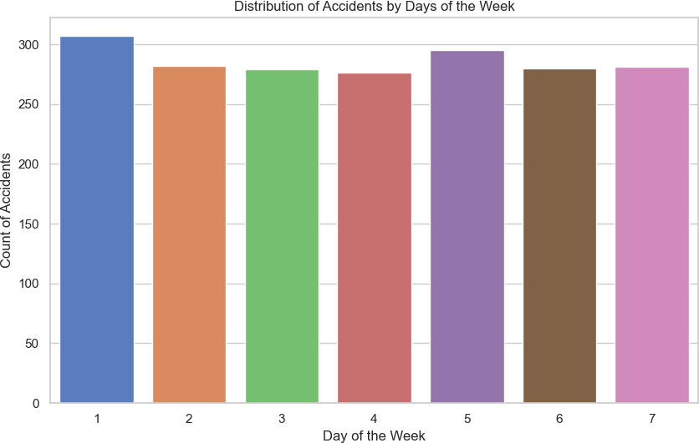

|  |  |
| --- | --- |
| 2) Median_Accidental_Severity | Total_Accidents |
| Bus 3.0 | 772 |
| Car 3.0 | 764 |
| Motorcycle 3.0 | 755 |
| Truck 3.0 | 709 |

1. Average_Accidental_Severity

|  |  |
| --- | --- |
| Vehicle_Type |  |
| Bus | 2.887118 |
| Car | 2.889333 |

Motorcycle 2.864130

Truck 2.872093\

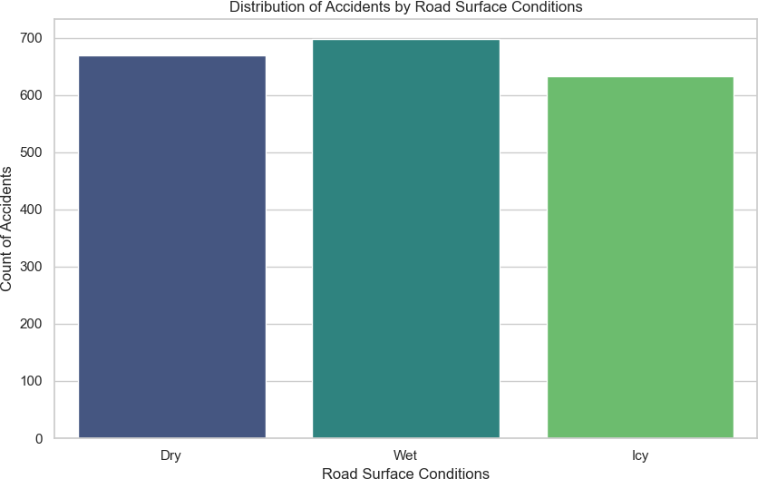

1. Average Severity for Motorcycle Accidents: 2.864130434782609 Total Motorcycle Accidents: 755

